

**Tutorial No. : 2**

**Title: Report on basic commands and scripting in Kali Linux**

# (A Constituent College of Somaiya Vidyavihar University)

**Roll No.: 16010420075 Tutorial No.: 2**

**Aim: Report on commands in Linux and writing scripts**

**Resources: Kali Linux OS, Any editor for documentation**

**Theory**

Kali Linux Commands is an advanced penetration testing distribution by offensive security. Its features allow users to create custom complex images with ease. Following are the must know Linux basic commands with examples:

1. Listing files (ls):

* If you want to see the list of files on your UNIX or Linux system, use the ‘ls’ command. It shows the files /directories in your current directory.
* Directories are denoted in blue color. Files are denoted in white. You will find similar color schemes in different flavors of Linux.
* You can use ‘ls -l’ to shows all the files not only in directories but also subdirectories

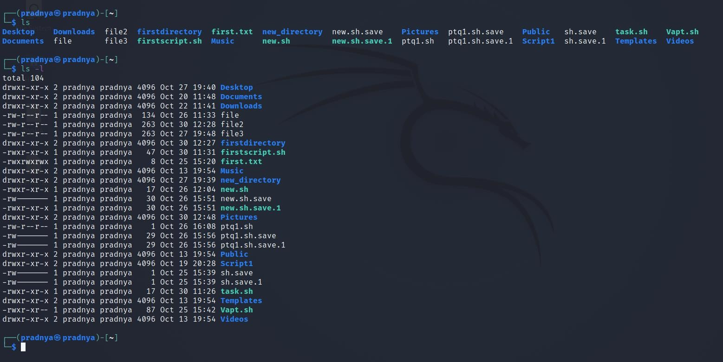

1. pwd (Print working directory): pwd stands for “Print Working Directory” which simply prints the name of the working directory

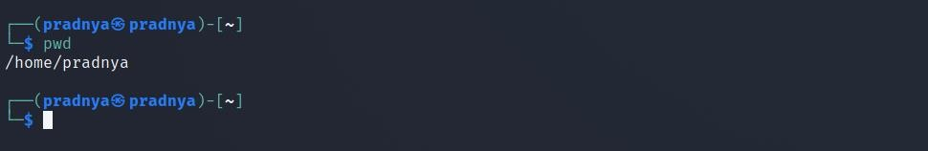

1. Date: This command is generally used to display the system date and time.

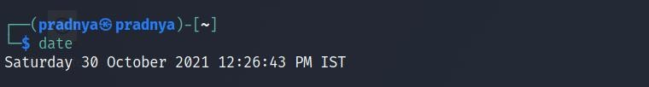

1. whoami: The whoami command simply prints the effective user ID whereas who command prints the information about users who are currently logged in.



1. mkdir: The command used for creating directories is mkdir. For e.g. mkdir

/root/Desktop/yeahhub



1. cat (concatenate): Command is one of the most frequently used command in Kali Linux which allows us to create single or multiple files, view contain of file, concatenate files and redirect output in terminal or files. E.g. $cat file1> file2



cat file1 file2>file2: Joins two files 1 and 2 and stores output of them in a new file3

1. cp (copy): This command is used to copy files or group of files or directory which creates an exact image of a file on a disk with different file name.



1. mv: The mv command moves, or renames, files and directories on your file system.

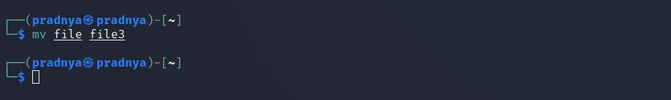

1. rm (remove):

* Command is used to delete files. When used recursively, it may be used to delete directories.
* The removal process unlinks a file name in a file system from its associated data, and marks that space on the storage device as usable by future writes.
* In other words, when you remove a file, the data in the file isn’t changed, but it’s no longer associated with a filename.

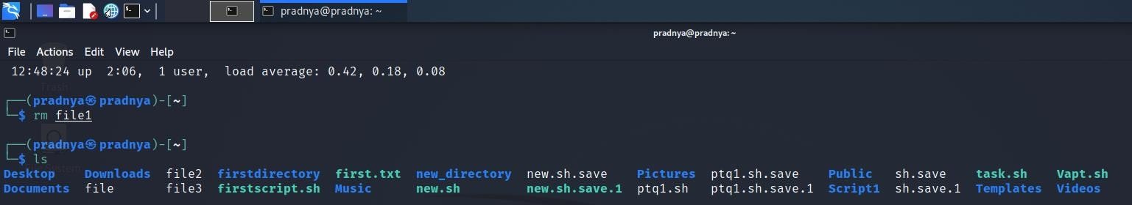

1. vi:

* The vi editor is a screen editor which is available on almost all UNIX systems. In general, vi has two modes: the command mode and the insert mode.
* To begin entering text in an empty file, you must first change from the command mode to the insert mode. To do this, type the letter i. When you start typing, anything you type will be entered into the file.
* Type a few short lines and hit Return at the end of each of line. Unlike word processors, vi does not use word wrap. It will break a line at the edge of the screen.
* If you make a mistake, you can use the Backspace key to remove your errors. If the Backspace key doesn’t work properly on your system, try using the Ctrl h key combination.

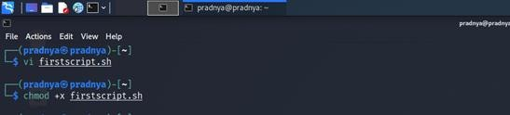

1. uname:

* This command prints the information about the current system. The uname command within Linux allows you to view system information about your Linux environment.
* With uname -a command, which gives you more information about the system like Kernel Name, Node Name, Kernel Release, Kernel Version, Machine, Processor, Hardware Platform and Operating system.

1. uptime: The uptime command gives you the time for which the system has been up (or running). Uptime’s basic usage is very easy – just write the command’s name and press enter.

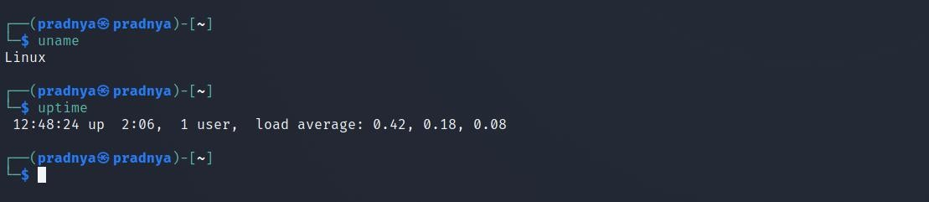

1. more: it is filter for paging through text one screenful at a time e.g. more myfile

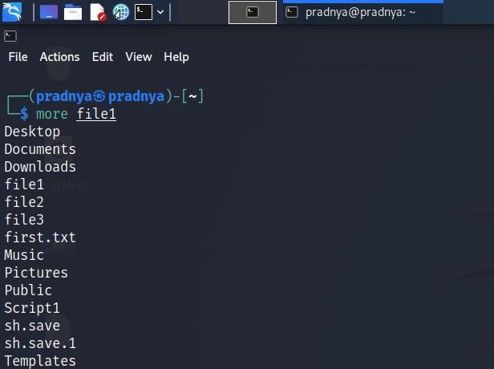

1. less: less command is used to view files instead of opening the file. The less command is considered to be a more powerful version of the “more” command which is used to display information to the terminal one page at a time.
2. chmod: To change file access permissions

* u- user who owns the file, g- group file owner, o- user classified as others, a- all other system user , + set permissions, - remove permission, r - read permission, w- write permission, x- execute permission
* e.g. $chmod x myfile



1. wc (word count): To count lines, words and characters of the given files. E.g. $wc –r myfile

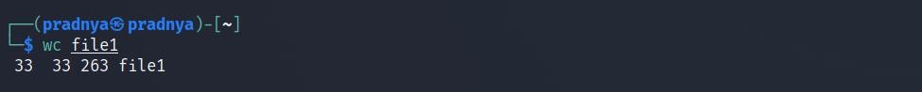

1. head: Used to print the first N lines of a file. It accepts N as a input and the default value of N is 10. E.g. $head -6 myfile
2. tail: used to print last N-1 lines of a file. It accepts n as input and default value of N is

10. E.g. $tail-5 myfile

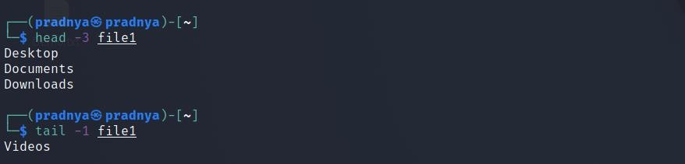

1. cmp: This command is used to compare the files. E.g. $cmp file1 file2



1. pr: this command is used to print the file. E.g. $pr file1
2. sort: Sort command sorts the contents of a text file, line by line. Sort is a standard command line program that print the lines of its input or concatenation of all files listed in its argument list in sorted order.

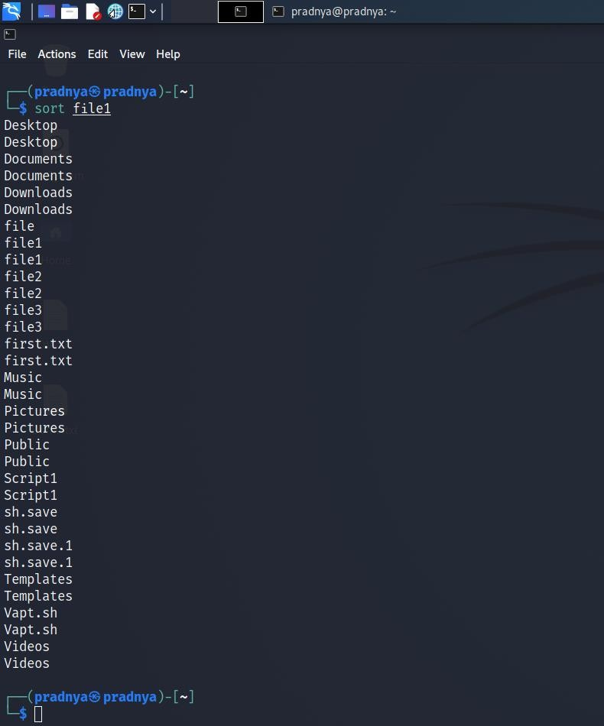

1. free: free is a command which can give us valuable information on available RAM in Linux machine. It also gives information about total used and available space of physical memory and swap memory with buffers used by kernel. E.g. $free
2. history: One of the extensively used command in Kali Linux is history command. The bash shell stores a history of commands entered, which can be used to repeat commands by using the history command. In simple manner, you can run the history command by itself and will simply print out the bash history of current user to the screen.

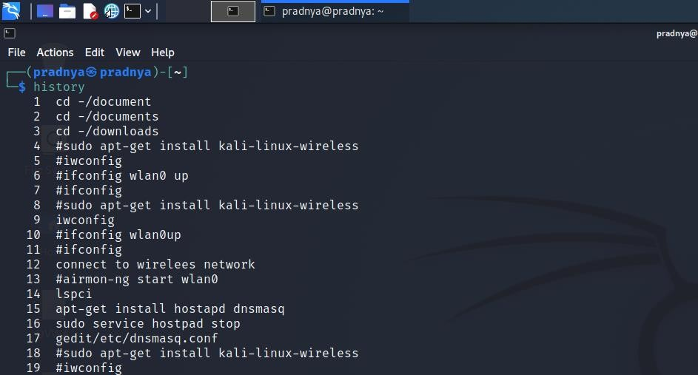

# Scripting in Kali Linux:

* Scripting allows for an automatic commands execution that would otherwise be executed interactively one-by-one. Shell is a macro processor which allows for an interactive or non-interactive command execution. Scripting is a way to execute all given commands together.
* Bash is a command language interpreter. It is widely available on various operating systems and is a default command interpreter on most GNU/Linux systems. The name is an acronym for the ‘Bourne-Again SHell’.
* A shell script is a file that contains ASCII text. To create a shell script, we use a text editor. A text editor is a program, like a word processor, that reads and writes ASCII text files. There are many text editors available for Linux systems, both for the command line and GUI environments. Some common ones are vi, gedit, nano, emacs, kwrite.
* Let's create a new shell script for that open vi editor to create new file firstscript.sh Once ready, make your new file executable using chmod command with an option +x. Lastly, execute your new script by prefixing its name with ./

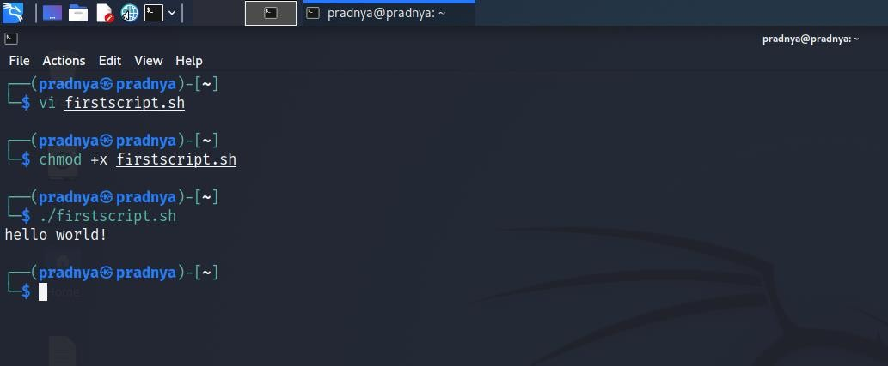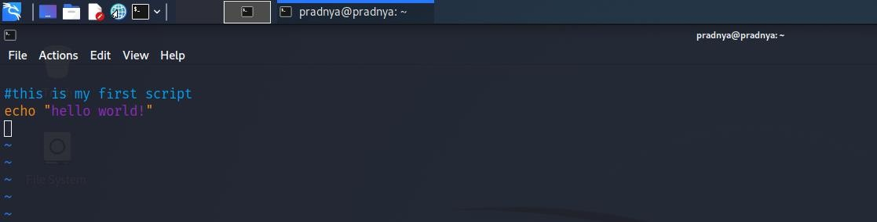

* The first line is a comment. Everything that appears after a "#" symbol is ignored by bash. As our scripts become bigger and more complicated, comments become vital. They are used by programmers to explain what is going on so that others can figure it out. The last line is the echo command. This command simply prints its arguments on the display.
* The next thing we have to do is give the shell permission to execute our script. This is done with the chmod command as $ chmod +x firstscript.sh. We can also give command as $chmod 777 firstscript.sh. The "777" will give us read, write, and execute permission. Everybody else will get only read and execute permission. To make the script private, (i.e., only we can read and execute), use "700" instead.
* Now to run our script give command as $ ./firstscript.sh. We should see "Hello World!" displayed. By use of scripting, any shell interaction can be automated and scripted.

**IMPLEMENTATION AND RESULTS:**

1. whoami

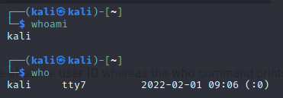

1. ls

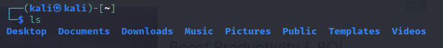

1. uname

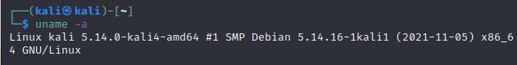

1. uptime

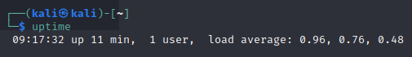

1. free

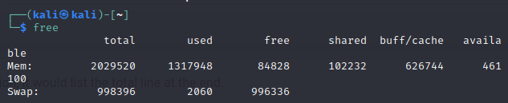

**Outcomes:** We have successfully created first script in Kali Linux called as “hello world!” There are many more commands related to kali Linux which can be used for ease of vulnerability assessment and penetration testing.

# Conclusion:

The Linux commands were successfully reported and executed in it’s terminal.

**Grade: AA / AB / BB / BC / CC / CD /DD**

**Signature of faculty in-charge with date**

**REFERENCES:**

1. Scripting tutorial for beginners: [https://www.linucconfig.com](https://www.linucconfig.com/)
2. Kali Linux commands: [https://www.javatpoint.com](https://www.javatpoint.com/)
3. Top 20 Kali Linux commands: [https://www.jigsawacademy.com](https://www.jigsawacademy.com/)
4. Top 20 basic kali Linux commands: [https://www.yeahhub.com](https://www.yeahhub.com/)